MAT264
Implied Volatility of European Option
Josh Villas- (villasjo)
Marko Rajicic- (rajicicm)
Nikita Nathania Rudy- (rudyniki)
Reynard Jonatan Kusnadi- (kusnadir)
Venturio Talenta Kusuma- (kusumave)
6th April, 2026

Mission I: Use S&P 500 option closing prices on 27 February 2026 for various maturities and strikes
We exported the data from the Bloomberg terminal. By going through SPX OMON in the terminal, then exporting manually for each expiration date, as the Bloomberg Excel API encountered connectivity errors during the data pull. We store the data in an Excel file: SPX OMON New.xlsx. It is stored based on the expiration date. Note that some of the data was missing due to missing historical data from Bloomberg, where it could just default to fill in the option information at the current time, rather than on the 27th of February. I highlight these “suspicious” option chains with the red colour in the sheets tab. But here, instead of a surface, we only evaluate the options on a couple of specific expiration dates.

Mission II: Collect risk-free interest rate data across maturities and build an interpolated interest-rate curve. Use this curve to obtain a rate for each option maturity in the dataset
We exported the data from the Bloomberg Terminal, where we used the YCGT0025 information. Then we store the information in the following Excel file: US Yield Curve 27022026 YCGT0025.xlsx. We then treat these data as nodes and interpolate them with Lagrange Interpolation and Cubic Spline interpolation.
Lagrange Interpolation
The Lagrange interpolating polynomial is the unique degree-n polynomial passing through n+1 nodes, 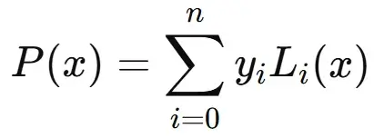 where each basis polynomial is 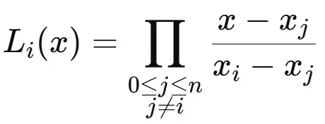. We constructed it manually rather than using a library so the failure mode is visible directly
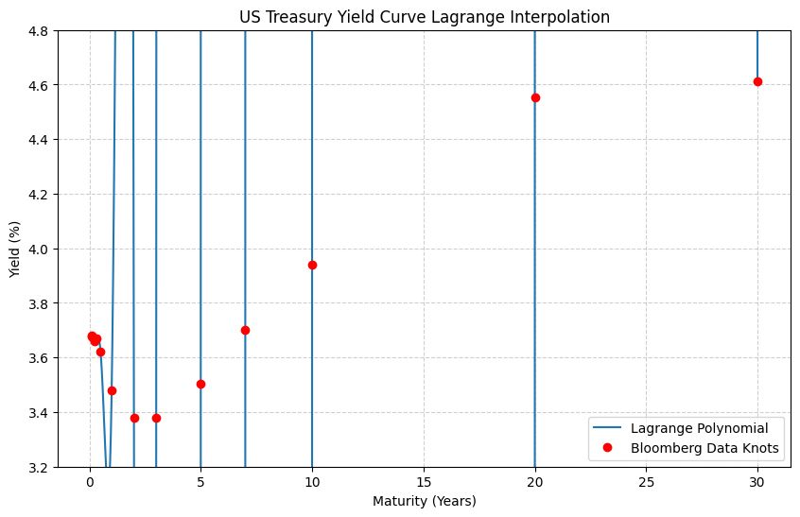
Cubic Spline Interpolation
The cubic Spline was obtained by fitting a cubic polynomial equation $S_{j}(x)=a_{j}+b_{j} (x − x_{j} )+c_{j} (x − x_{j} )²+d_{j} (x − x_{j} )³$
On each interval ${[X}_{j}, X_{j+1}]$ for $j∈[0,13]$, joining the pieces so that the spline, its first derivative, and its second derivative are all continuous at every interior knot. Imposing the natural boundary conditions S″(x ) = S″(x ) = 0 closes the system, which we then solve as a tridiagonal linear system.
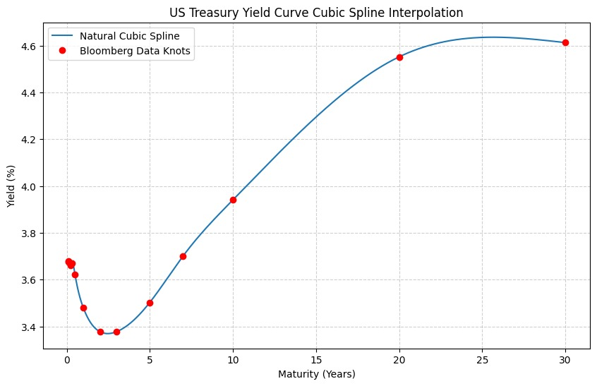
Why does cubic spline beat polynomial interpolation here?
The Lagrange fit and the spline agree at the nodes, but they differ wildly between them. Three reasons make the cubic spline strictly preferable for yield-curve work:
- No Runge's phenomenon. A high-degree polynomial forced through many nodes oscillates uncontrollably between them, especially near the endpoints. With 14 nodes the degree-13 polynomial blows past ±100% in the 1Y–10Y belly of the curve, a region where we actually need accurate rates for option pricing. The cubic spline stays bounded by construction because each piece is only a cubic.
- Locality. The Lagrange polynomial is global: changing the value at the 30Y node distorts the curve at every other tenor. The cubic spline is local, a perturbation at one knot only meaningfully affects the two or three adjacent intervals not strongly changing the global curve. This matches how real yield curves behave: a Fed cut moves the front end without re-shaping the long end.
- Smoothness without overfitting. The spline is C² continuous, so the implied forward-rate curve (the derivative) is also continuous and well-behaved. We can therefore call r(T) at any option maturity in the dataset and trust the result. For each option we evaluate r = spline(T)/100 and feed it directly into the Black–Scholes formula. For example, at T ≈ 0.211 y the spline returns r ≈ 3.66%, and at T ≈ 0.806 y it returns r ≈ 3.52%.

Mission III: Implement the Black–Scholes formula for European calls or puts.
Black Scholes formula
Specifically, the following formula is derived from the model:
- 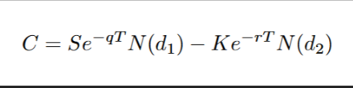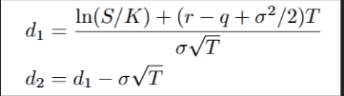
The involved variables are as follows:
- S: Current Asset Price
- T: Time of Expiry
- K: Strike Price (agreed upon selling)
- sigma: Implied volatility based on the price movement of the S&P 500 in one year.
- q: Annual dividend stock pays as fraction of current price
- N: CDF of Normal Distribution
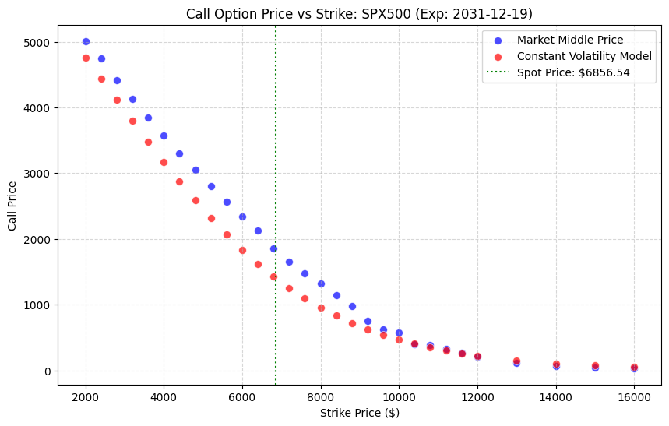
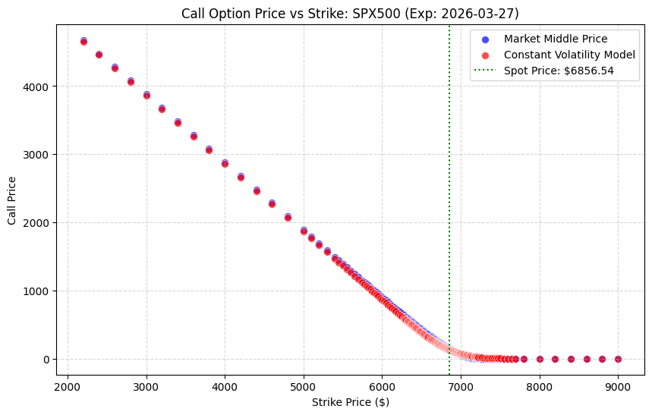
Notice that in the shorter term, a constant volatility produces prices close to the market price. This is due to the impact of T being so small that the impact of volatility gets dominated/minimized by the T. However in the longer term, we see that the constant volatility assumption produce call prices that diverge from the market price.

Mission IV: For each option, compute implied volatility using a root-finding method (such as Newton’s method).
Newton’s Method
In Newton’s method, we define $x_{n+1} = x_{n} - \frac{f(x_{n})}{f'(x_{n})}$ where $f(x)$ f is the function that you want to find the root of. Now, we just need to modify it to fit into our context of Black-Scholes. So, it becomes $σ_{n+1} =σ_{n} -\frac{BS(σ_{n}) - P_{market} }{Vega(σ_{n})}$. We want to find the root of $BS(σ_{n}) - P_{market}$ where the root ${σ*}_{}$represents the specific volatility level that equates the model price to the observed market price. We also chose to describe f’(x) as $Vega(σ_{n})$ because Vega is mathematically defined as the first partial derivative of the Black-Scholes pricing function with respect to volatility $\frac{∂BS}{∂σ}$. The following list shows the other 5 inputs for the Black-Scholes formula:
- T: We simply convert the time it takes from the 27th of February 2026 to the expiration date in years.
- S: We look for the spot price of the S&P 500 Index as of 27th February 2026, which we found to be 6856.54.
- r: Take advantage of the function we interpolated in the first part and fetch the Yield for a specific time to expiration.
- K: The strike prices available for that expiry date.
- q: Dividend yield of S&P 500 on the 27th February 2026, which we found to be 0.0122.
For the initial guess, we hard-coded 0.5 since a lot of sources like Bloomberg and Yahoo show that the implied volatility of the S&P 500 ranges from 0.1 to 1.0. Alternatively, we could use the bisection method for a few steps to find a good initial guess, then move from there, but this hasn’t been implemented in the current code. We then set the tolerance $BS(σ_{n}) - P_{market}$ to be less than 10⁻⁶. The reason we picked 10⁻⁶ as our tolerance is that as the tolerance gets lower, there is a risk of introducing floating errors from the computer. To avoid introducing a new type of error, we keep it at 10⁻⁶. As it hits the tolerance threshold, we stop iterating and keep track of how many iterations it takes and the implied volatility.
Remark:
For the Newton Method to converge quadratically, it needs to satisfy three conditions:
- $f ∈ C^{2}$ (Twice Differentiable) which we know will always be satisfied in this problem because the Black Scholes function is an exponential function (Specifically, the N).
- $f'(σ) ≠ 0$ which is also always satisfied because $T ≠ 0$.
- $σ_{0} ∈ [σ*-δ, σ* + δ]$. This condition is not always fulfilled, as we will discuss.
From the observed data, notice that in most cases, the model only requires 4 iterations, which means that our initial guess mostly converges quadratically. This implies that most of the $σ_{0 }=0.5$ were close enough to the real $σ*$. However, there are also cases where our initial guesses were not close enough that they required a few steps before converging to less than 10⁻⁶. Worse, there are some cases deep in the money (strike prices much less than spot prices) where Vega is really close to zero. This causes some calculations to explode and stops the program due to a Zero Division Error. Therefore, in cases like this, we decided to add a small step of (10⁻¹⁵) on the vega just to prevent zero division and dropped the nodes from the calculation. This is the reason that some of the nodes are really close to 0.
Example of the iterations at T = 5.810959, K = 2000.0, C = 5009.398438, S = 6856.54, r = 0.035814, q = 0.0122 as follows (Note that it might slightly differ from the vectorized form due to hardcoded numbers for this iterations).
Iter | Implied Volatility | Model Price | Vega | Error(Difference)
0 | 0.500000 | 4983.093600 | 1354.875654 | 26.304838
1 | 0.519415 | 5009.850065 | 1400.280825 | -0.451627
2 | 0.519092 | 5009.398551 | 1399.580862 | -0.000113
3 | 0.519092 | 5009.398438 | 1399.580686 | -0.000000
For the bigger picture, we also have these table for the long term implied volatility and short term implied volatility: implied_volatility_results_short_term.xlsx and implied_volatility_results_long_term.xlsx.

Mission V: For at least one fixed maturity, plot implied volatility versus strike and demonstrate the volatility smile. If possible, compare across maturities.
Shorter Expiration Date (Volatility Smile)
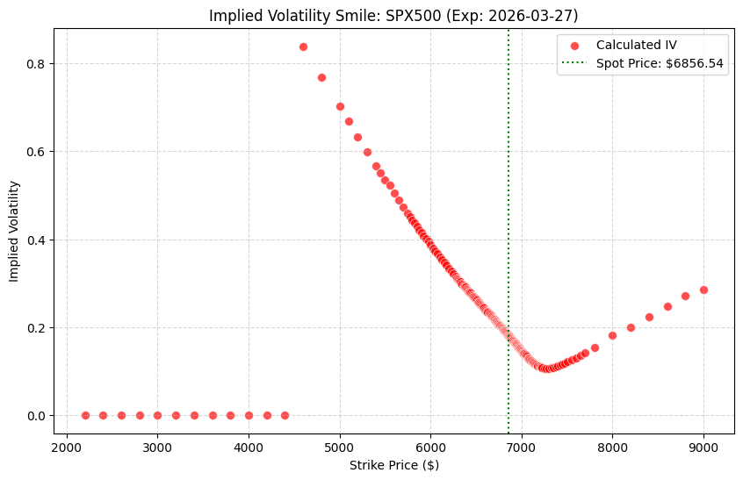
Longer Expiration Date (Volatility Skew)
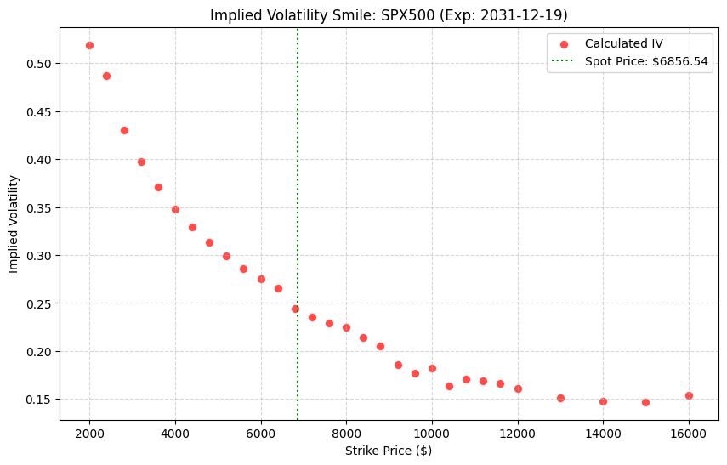

Comparison across different Time Expirations on specific Strikes
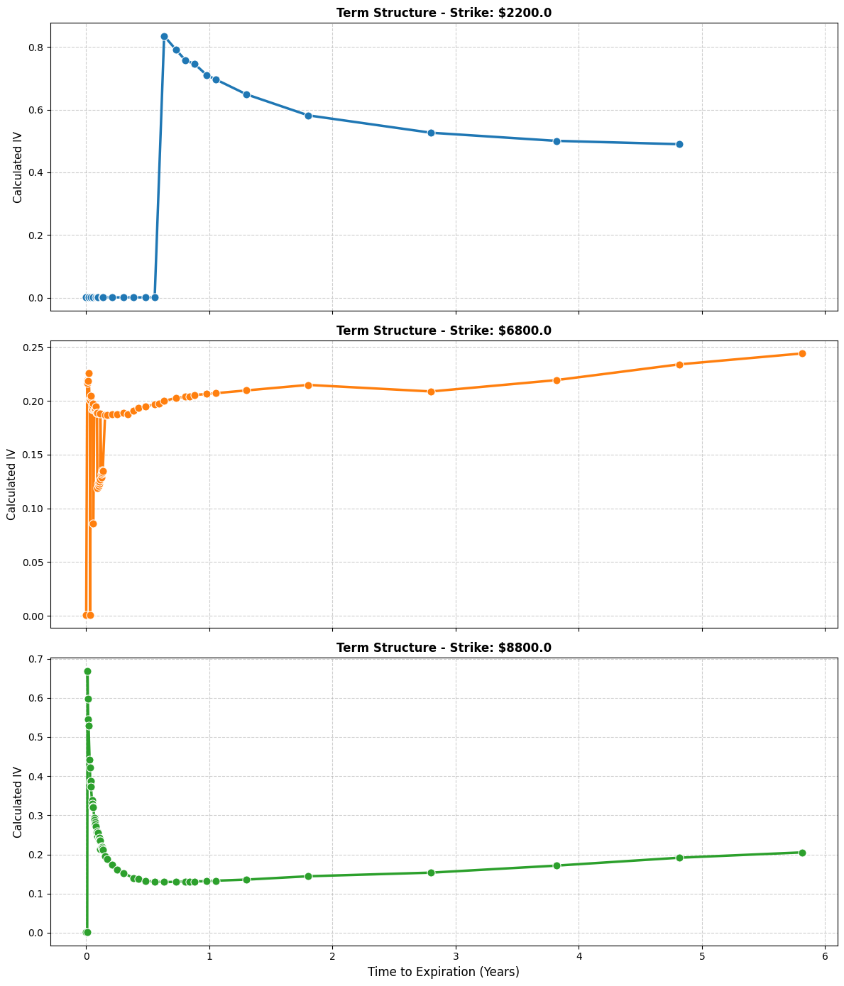

Mission VI: Discuss why the Black–Scholes constant-volatility assumption is not reflected in market data.
As we have shown in Mission V, the market price does not reflect constant volatility. For this, we have a couple of explanations as follows:

1. Returns have fatter tails than the lognormal
Black-Scholes assumes log-returns are normally distributed. Empirically, equity returns exhibit excess kurtosis: large moves, both up and especially down, happen far more often than a Gaussian predicts. To match the observed prices of OTM options (which pay off precisely in those large-move scenarios) the market must use a higher σ than for ATM options. This produces the characteristic upturn at the wings of the smile

2. The leverage effect
Equity returns are negatively correlated with volatility: when prices fall, realized volatility tends to rise (a falling equity raises a firm's leverage ratio, making its remaining equity riskier). Black–Scholes assumes σ is independent of S, so it cannot reproduce this correlation. The market prices it in by demanding richer protection on the downside, exactly the asymmetric skew we observed.

3. Volatility clustering and stochastic volatility
Realised volatility itself varies over time, and it varies in clusters: quiet periods are followed by quiet periods, turbulent periods by turbulent periods. GARCH-family models and stochastic-volatility models such as Heston (1993) explicitly model σ as a mean-reverting random process, and they fit market smiles much better than Black–Scholes. The fact that these models exist and are widely used in industry is itself an indictment of constant volatility

4. Jump risk and crash premia
After Black Monday in October 1987, the SPX skew became permanent. The market now charges an explicit premium for jump risk that the diffusive Black–Scholes dynamics simply cannot generate. Merton's jump-diffusion model (1976) extends Black–Scholes by adding a Poisson jump component and reproduces a smile naturally; Black–Scholes alone cannot

In short, Black–Scholes is an extraordinarily useful first-order model: it gives every traded option a single, comparable number (the implied vol) and it is the lingua franca in which option markets quote prices. But the constant-volatility assumption is not a feature of the world; it is a modelling convenience whose failure is precisely what the volatility smile measures.

Conclusion
We collected SPX option closing prices from the Bloomberg Terminal for 27 February 2026 across 58 expiration dates, and built a US Treasury yield curve from the YCGT0025 actives. Comparing Lagrange polynomial interpolation against natural cubic splines made the case for splines visually obvious: the degree-13 Lagrange polynomial is destroyed by Runge's phenomenon, while the cubic spline produces a smooth, local, well-behaved r(T) function we can query at any option maturity.
We then implemented the Black–Scholes formula with a continuous annual dividend yield, derived the Newton update $σ_{n+1} =σ_{n} +\frac{BS(σ_{n}) - P_{market} }{Vega(σ_{n})}$, and applied it to two representative SPX expiries (May 2026 and December 2026). Convergence was fast — under four iterations on average — and our computed IVs matched Bloomberg's IVM column to within roughly 1.5–2.2 percentage points across both chains.
Plotting IV against strike confirmed the textbook SPX smirk: a steep downward skew through the at-the-money region with a mild upturn for far OTM calls. Comparing across maturities showed the flattening of the smile with time to expiry. Both observations contradict the constant-σ assumption baked into Black–Scholes, driven empirically by fat tails, the leverage effect, stochastic and clustered volatility, jump risk, and the genuine term structure of σ. Black–Scholes remains an indispensable common language for quoting and comparing options, but the shape of the smile is precisely the measure of how far reality has drifted from its assumptions.

References
Black, F., & Scholes, M. (1973). The pricing of options and corporate liabilities. Journal of Political Economy, 81(3), 637–654. https://doi.org/10.1086/260062
Wang, Q. (2026). Introduction to Numerical Analysis [Lecture notes]

